# Test Design and Bug Challenge

## Requirements for Test

Given the application under test (AUT): <https://openweathermap.org/>

Feature: Search weather in your city

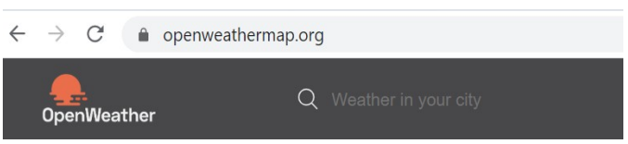

Create a Test approach for the given feature based on your Exploratory Testing skill (Different Test Type, Test Level, Test Coverage) (Please provide your assumptions in the requirement as long as they are reasonable).

## Test Approach

### Test type definition

|  |  |  |
| --- | --- | --- |
|  | **Unit Test (UT)** | **System Intergration Test (SIT)** |
| Function | ☑ | ☑ |
| Performance test/Stress test |  | ☑ |
| Regression test |  | ☑ |

### Test level definition

|  |  |  |
| --- | --- | --- |
| **Test level** | **Test type** | **Approach** |
| System Intergration Test (SIT) | Functional testing | - “Search weather” feature on Website  - “Search weather” feature by API |
| Performance testing | Performance testing | - Performance testing for “Search weather” feature (Normal and Peak hour concurrent users/transaction)  - Mix scenario (mixed all functions) (Normal and Peak hour concurrent users/transaction)  - Soak test in 1 day with workload |

## SIT plan and scope/out of scope

1. Unit testing/automation testing

* API validation and functional belong automation test scope

1. SIT Testing

1.Scope of function

|  |  |  |
| --- | --- | --- |
| **No** | **Scope testing** | **Description** |
| 1 | Search weather in your city on Application: <https://openweathermap.org/> | - Check GUI “Search weather in your city” in the browser (Chrome, Firefox, IE, Safari on Web and Mobile platform)  - Check Result of “Search weather in your city” with input valid  - Check “Search weather in your city” by languages (English, Vietnamese, Chinese, Japanese…)  - Check Result of “Search weather in your city” with input invalid (city not exists, include special chars,…) |
| 2 | Search weather in your city by API: [https://api.openweathermap.org/data/2.5/weather?q={{city_name}}&appid={{api_key}}](https://api.openweathermap.org/data/2.5/weather?q=%7b%7bcity_name%7d%7d&appid=%7b%7bapi_key%7d%7d) | - Check Response for “Search weather in your city” API with input valid  - Check Response for “Search weather in your city” API by languages (English, Vietnamese, Chinese, Japanese…)  - Check Response for “Search weather in your city” API with input invalid (city not exists, include special chars,…)  - Build automation test framework for api |

2.Out of scope testing

|  |  |  |
| --- | --- | --- |
| **STT** | **Function** | **Functions not testing** |
| 1 | Search weather in your city on Application | - Validate result search with data in Database.  - Other feature “Search weather in your city” don’t execution  - Don’t build automation test framework for Application on GUI |
| 2 | Test performance/Stress test for Application | In scope of Performance Test Team |

1. Performance testing

|  |  |  |
| --- | --- | --- |
| **STT** | **Item** | **In Scope testing** |
| 1 | Search weather in your city | Yes |

3.Test plan

|  |  |  |  |  |  |  |  |  |
| --- | --- | --- | --- | --- | --- | --- | --- | --- |
| **STT** | **Test item** | **Priority** | **Person in charge** | **Start date** | **End date** | **Out of scope** | **Risk** | **Progress** |
| **I.** | **Test case** | | | | | | | |
| I.1 | **Search weather in your city on Application:** <https://openweathermap.org/>  - Design testcase  - Write Testcase  - Prepare datatest | High | QuangDT | 2022-02-19 | 2022-02-19 |  |  | Done |
| I.2 | **Search weather in your city by API:** [https://openweathermap.org/find?q={city name}](https://openweathermap.org/find?q=%7bcity%20name%7d)  - Design testcase  - Write Testcase  - Prepare datatest | High | QuangDT | 2022-02-20 | 2022-02-20 |  |  | Done |
| **II** | **Test team prepare** | | | | | | | |
|  | Preparing test tools  - Browser: Chrome, Firefox, Safari, IE  - Postman  - Framework auto test | High | QuangDT | 2022-02-19 | 2022-02-22 |  |  | Done |
| III | **Smoke test** | | | | | | | |
| III.1 | **Web Application**:  - Get information weather for your city successfully with input valid  - Get information weather for your city unsuccessfully with input invalid | High | QuangDT | 2022-02-20 | 2022-02-20 |  |  |  |
| III.2 | **API**:  - Get information weather for your city successfully with parameter valid  - Get information weather for your city unsuccessfully with parameter invalid | High | QuangDT | 2022-02-20 | 2022-02-20 |  |  |  |
| **IV** | **Test execution** | | | | | | | |
| IV.1 | **Web Application:** <https://openweathermap.org/>  - Testing Execution  - Report result | High | QuangDT | 2022-02-19 | 2022-02-20 |  |  |  |
| IV.2 | **API:** [https://openweathermap.org/find?q={city name}](https://openweathermap.org/find?q=%7bcity%20name%7d)  - Testing Execution  - Report result | High | QuangDT | 2022-02-20 | 2022-02-21 |  |  |  |
| **V** | **Build automation test framework** | | | | | | | |
|  | Search weather in your city by API: [https://openweathermap.org/find?q={city name}](https://openweathermap.org/find?q=%7bcity%20name%7d)  - Build framework  - Create Test Script  - Ingration libration report test, CICD  - Run Test  - Check report | High | QuangDT | 2022-02-21 | 2022-02-26 |  |  |  |

## Report result and Detail Defect

### Summary report

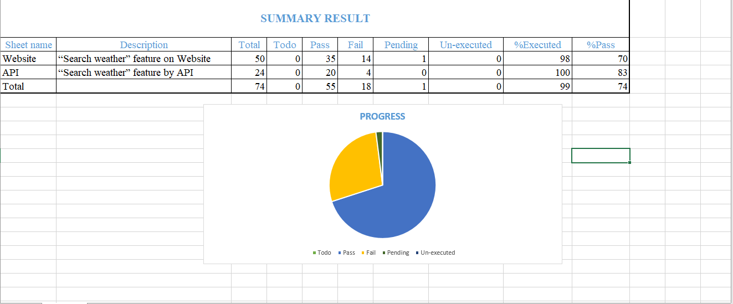

**Image 1***: Summary report run manual*

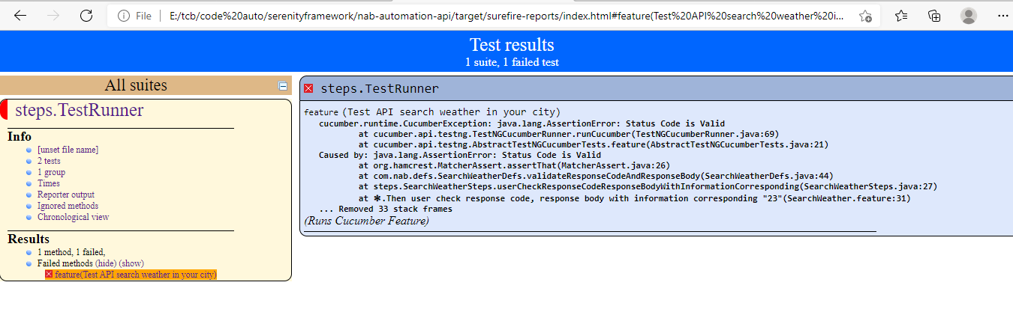

**Image 2***: Summary report run by framework automation test*

### Detail Defect for Web Application

|  |  |
| --- | --- |
| **ID** | **Nab_Defect_001** |
| **Summary** | **[SIT]_[SearchWeather] Still return infor weather when search weather with city_name is space string** |
| Environment | Chrome, Firefox, IE |
| Description | Precondition: Open browser  Step:   * 1.Go to: https://openweathermap.org/ * 2.Input “City Name” = “ ” (space string) * 3.Press "Enter" key * 4.Check result search weather   Actual Result:   * System return infor weather for city Xankandi, AZ   Expected Result:   * Show message "Enter City Name " |
| Priority | Medium |
| Severity | Medium |
| Label | SIT, WEB |
| Link | TC_ID_WEB_8, TC_ID_WEB_17 |
|  |  |
| **ID** | **Nab_Defect_002** |
| **Summary** | **[SIT]_[SearchWeather] Don’t return message require user input city name when City_Name is EMPTY** |
| Environment | Chrome, Firefox, IE |
| Description | Precondition: Open browser  Step:   * 1.Go to: https://openweathermap.org/ * 2.City_Name is EMPTY * 3.Press "Enter" key * 4.Check result search weather   Actual Result:   * System don’t show message require user input city name to search weather   Expected Result:   * Show message "Enter City Name " |
| Priority | Medium |
| Severity | Medium |
| Label | SIT, WEB |
| Link | TC_ID_WEB_7, TC_ID_WEB_16 |
|  |  |
| **ID** | **Nab_Defect_003** |
| **Summary** | **[SIT]_[SearchWeather] Don’t return message require user input correct city name when City_Name is abbreviation city name** |
| Environment | Chrome, Firefox, IE |
| Description | Precondition: Open browser  Step:   * 1.Go to: https://openweathermap.org/ * 2.Input City_Name is “HN” – abbreviation city name of “Ha Noi” * 3.Press "Enter" key * 4.Check result search weather   Actual Result:   * System don’t show message require user input correct city name to search weather   Expected Result:   * Show message “Name city not found" |
| Priority | Medium |
| Severity | Medium |
| Label | SIT, WEB |
| Link | TC_ID_WEB_10, TC_ID_WEB_19 |
|  |  |
| **ID** | **Nab_Defect_004** |
| **Summary** | **[SIT]_[SearchWeather] Don’t return message when City_Name has length >80 chars** |
| Environment | Chrome, Firefox, IE |
| Description | Precondition: Open browser  Step:   * 1.Go to: https://openweathermap.org/ * 2.Input City_Name*: Krungthepmahanakhon Amonrattanakosin Mahintharayutthaya Mahadilokphop Noppharatratchathaniburirom Udomratchaniwetmahasathan Amonphimanawatansathit Sakkathattiyawitsanukamprasit* (length > 80 chars) * 3.Press "Enter" key * 4.Check result search weather   Actual Result:   * System don’t show message for user   Expected Result:   * Show message City name too long" |
| Priority | High |
| Severity | Medium |
| Label | SIT, WEB |
| Link | TC_ID_WEB_14, TC_ID_WEB_23 |
|  |  |
| **ID** | **Nab_Defect_005** |
| **Summary** | **[SIT]_[SearchWeather] Don’t auto strim space first/between/last string before search weather** |
| Environment | Chrome, Firefox, IE |
| Description | Precondition: Open browser  Step:   * 1.Go to: https://openweathermap.org/ * 2.Input City_Name*: “ Bắc Giang, VN” (space at first string)* * 3.Press "Enter" key * 4.Check result search weather   Actual Result:   * System show message “not found”   Expected Result:   * System auto trim space at first/between/last string and return weather for entered city |
| Priority | High |
| Severity | Medium |
| Label | SIT, WEB |
| Link | TC_ID_WEB_35, TC_ID_WEB_36, TC_ID_WEB_37, TC_ID_WEB_48, TC_ID_WEB_49, TC_ID_WEB_50 |

### Report Test Exection for API by Runner in POSTMAN

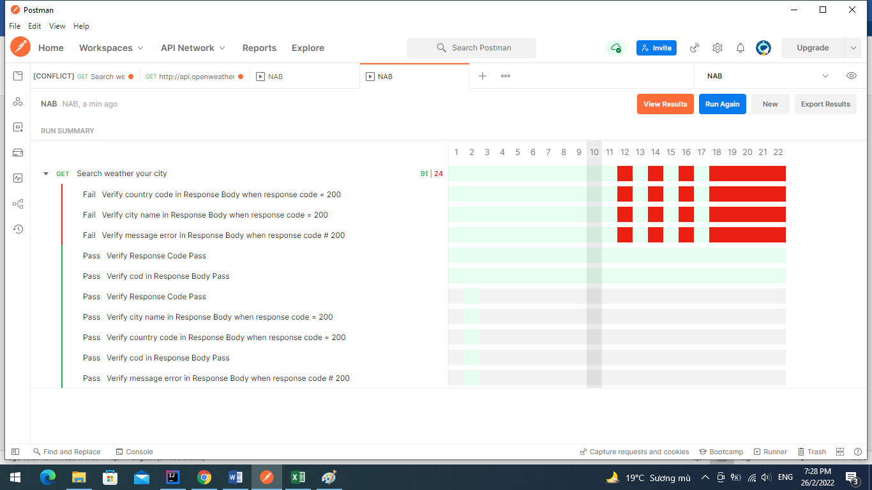

### Report Test Exection for API by framework automation test

